iSiMAR, manufacturers of outdoor furniture,
presents the new KiDS collection
iSiMAR KiDS is conceived for bring life to the outdoors.
Resistant, durable furniture made from sustainable materials.
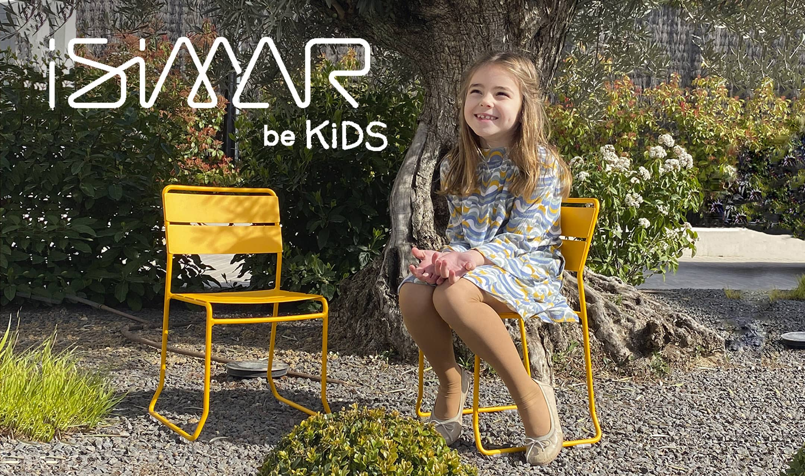

Pamplona, June 27th, 2022. iSiMAR, manufacturers & designers of outdoor wire furniture, presents the new KiDS collection. A capsule collection of 7 pieces designed for children between 3 and 9 years old. Contemporary and colorful designs, with a lot of custom options and made of sustainable materials. Check them out on the official website www.isimarkids.com & on social media @isimarkids.

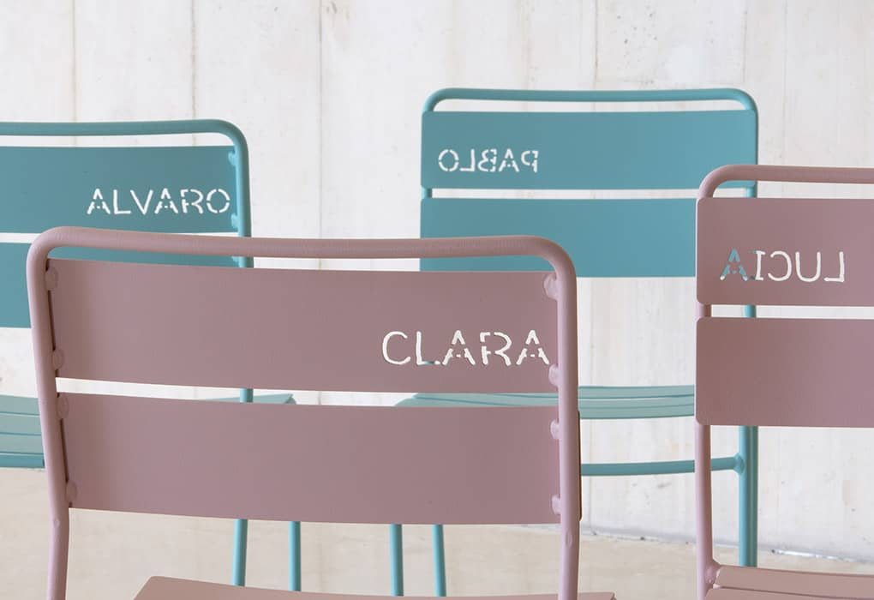
Special furniture
‘A few months ago we began to
design our new and exciting project, created to bring joy and fun to many homes, gardens and other spaces.
iSiMAR KiDS was developed to join our little ones throughout their childhood, making their surroundings bright and colorful,’ said Luis Unceta, CEO of iSiMAR.

About iSiMAR

iSiMAR is a Spanish company that designs and manufacturers metal furniture for indoor and outdoor use. Born in 1964, iSiMAR has being able to adapt and change its business model according to the market’s demands and is now present in more than 45 countries. Both the factory and headquarters are located in Navarra, Spain. iSiMAR is also present in the North American market with a permanent office in NYC. Other subsidiary offices are located in London and Mexico.
iSiMAR's designs are inspired by Mediterranean origins, referencing a lifestyle based on joy, outdoor spaces and naturalness. The products are made of recycled & recyclable materials. The collections are also created for professional use: stackable, for easy transport in large quantities, resistant to exposure to the elements, humid and saline environments, offering maximum durability.

Para más información:

kids@isimarkids.com | www.isimarkids.com
marketing@isimar.es | www.isimar.es
ES: +34 948 318 465

